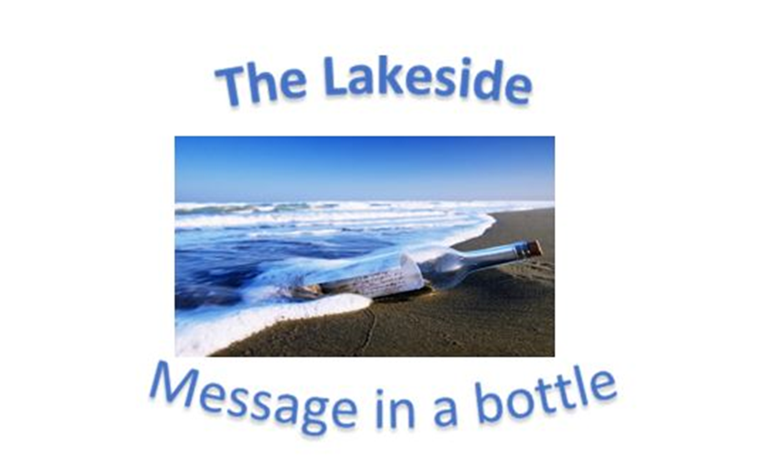
Verse of the day for Monday September 25, 2023 – II Corinthians 21: 9-10

9 But he said to me, “My grace is sufficient for you, for my power is made perfect in weakness.” Therefore I will boast all the more gladly about my weaknesses, so that Christ’s power may rest on me.
10 That is why, for Christ’s sake, I delight in weaknesses, in insults, in hardships, in persecutions, in difficulties. For when I am weak, then I am strong.

Read II Corinthians 12: 9-10 for meditation and inspiration.

WORLD COMMUNION
Dear Lakesiders and friends,
There is an old saying that goes something like this:
To look is one thing.
To see what you look at is another.
To understand what you see is still something else.
But to act on what you learn is what really matters.

The world can be a frightening place. There is so much corruption and crime displayed on our TV screens at home and around the world. Think of what would happen if everyone who called themselves Christians set out to change it all! I mean millions and millions of people saying enough is enough! We want our world back for our Creator and King, Jesus the Christ.

Well, this is the time to consider such a dream. On the first Sunday of October, increasing numbers of churches participate in World Communion Sunday, a time when Christians everywhere celebrate what it means to belong to "the holy catholic church, the communion of the saints." Indeed, the church is the one body of Christ, our head. In Holy Communion, we most deeply celebrate our oneness in Christ. One way to remember the larger body of Christ is to offer prayers and songs.

In terms of what God is doing in our Church – and in our homes and our cities and our world – we first need to be continually reexamining our role as Churchgoers. Week-in and week-out, we need to look and to see and to understand, and then to act on what we learn. We always need to ask ourselves, are we spectators or participants? Are we detached, or are we involved? Are we giving mere lip service to the Good News of New Life in Christ, or are we experiencing it? Are we watchers, or are we doers?

God's formula for happiness should not languish somewhere between your knowing it and doing it. If your neighbor needs material support, don't let your money languish in your wallet. If a sinner is asking forgiveness, don't let your compassion languish in your heart. If a stranger longs for a friend, don't let your companionship languish in your busy calendar.

Our world is full of misery and fear and ignorance. Our Christian duty is to make the little corner of our influence less distant and more intertwined with God’s grace and then ask our sisters and brothers around the world to join us in this revolution of

Love in Communion,

Roger

