Verse of the day for Monday September 17, 2023 – Ephesians 2: 8

8 For it is by grace you have been saved, through faith—and this is not from yourselves, it is the gift of God—

Read Ephesians 2 for meditation and inspiration.

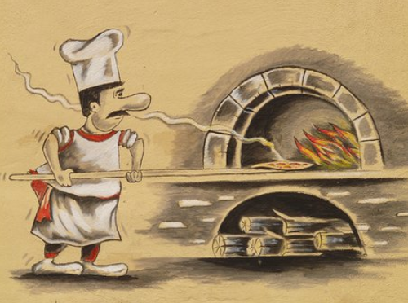

BEST PIZZA IN THE SOLAR SYSTEM!!!
Dear Lakesiders and friends,
A funny thing happened several years ago in New York City: five new pizza parlors with five different owners opened in the same block. It soon became apparent that there wasn't nearly enough business in the neighborhood to support all five, so the competition to survive became fierce. As part of his campaign to attract customers, one of the owners put up a sign which read: "Ours is the best pizza in the city." The others quickly followed his lead. "Ours is the best pizza in the state," said the second owner's sign. The third owner's read: "Ours is the best pizza in the country." Not to be outdone, the fourth owner erected a sign boasting, "Ours is the best pizza in the world." Finally, the fifth owner's sign went up. The clear winner, it read ...
"Ours is the pizza best on the block."
No doubt about it, the competitive spirit was alive and well in that neighborhood.
Maybe competition is not the last word in life. Some years ago a pastor stated in a sermon that “life in not a competition but a cooperation.” Calls, emails, notes and letters came in to denounce this idea. Each person was ready to inform the pastor how naive and out of touch he was. Life is all about competition, about getting ahead, about outclimbing the other guy on the ladder of success. Life is competitive. Maybe true but what if you outrun, out claw, out scramble, out do others and gain your desired victory, what then? Jesus said, “The Cross and Self-Denial is often the cost of discipleship.” In Matthew 16:24 – 27, it is recorded: “Then Jesus told his disciples, ‘If any wish to come after me, let them deny themselves and take up their cross and follow me. For those who want to save their life will lose it, and those who lose their life for my sake will find it. For what will it benefit them if they gain the whole world but forfeit their life? Or what will they give in return for their life?‘ For the Son of Man is to come with his angels in the glory of his Father, and then he will repay everyone for what has been done.’”
For discipleship,
Roger

