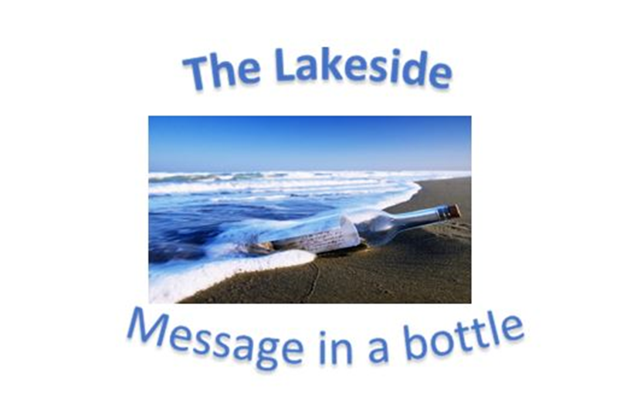
Verse of the day for Monday August 21 2023 – James 2: 17

17 In the same way, faith by itself, if it is not accompanied by action, is dead.

Read James 2 for meditation and inspiration.
LET US BRING OUR CHILDREN TO THE KING
TO START THEM RIGHT

Dear Lakesiders and friends,
Some years ago, the pollster George Gallup was asked to comment on what his polls were saying about "the correct state of religion in America." What he said, in part, seems as relevant today, as ever ...
The two major trends really are a search for depth in our society - people seeking spiritual moorings -- and the search for relationships. People need to rediscover each other... We are fragmented. Families are split apart.
Mr. Gallup went on to describe many American church-goers as assenters rather than believers: They assent to faith. They assent to the beliefs which one so meant to believe, but they don't necessarily believe them. If you consider that a belief is something to be acted upon, then these people are merely paying lip-service to what they think they should believe. If we were truly as religious as we sound, the ethical nature of our society would be vastly different. To which I will add, how we long for that day.
We think of faith in terms of belief, and rightly so. Faith is believing in something. It has been said that faith is believing what you know is true but cannot be proven on any rational level.
But in Gospel terms, belief is simply the doorway to the House of Faith. Matthew's Gospel contains an incident in which Jesus spells this out clearly and directly. In the story, the people are trying to bring their children to Jesus and the disciples are trying to get the children out of His way. In their view, Jesus has more important things to do than to be bothered with the antics of little children. Jesus makes it clear that Jesus is the Savior who came to save all and that includes families and their children. He then acted upon it by placing his hand of mercy and grace upon those little heads.
If we believe, we must act. Belief is the starting point, the place where the race of new life begins and the starting gun has fired. Hear its sharp sound, run the course and He will run beside you - but you must run. Be doers of the WORD not hearers only!
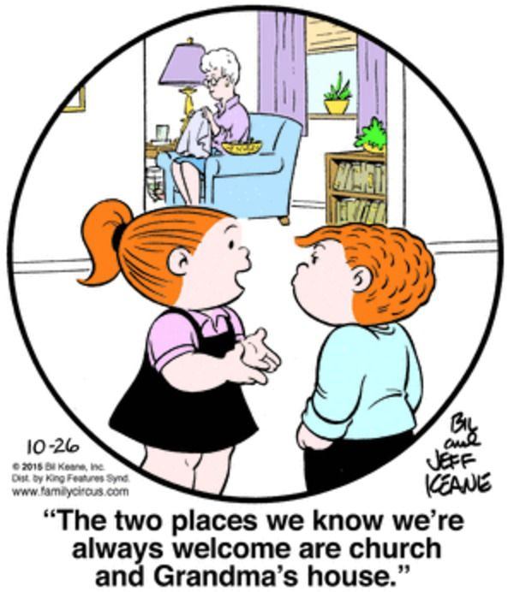
Let us act on what we say we believe.
Grace and Peace,

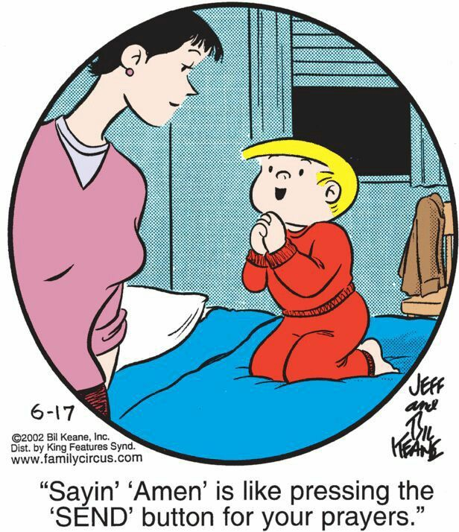
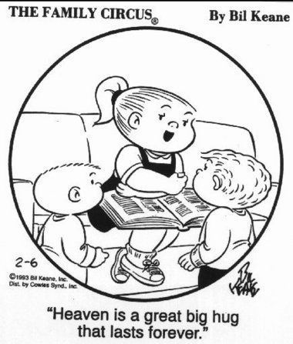
Roger

