Verse of the day for Monday September 11, 2023 – Psalm 46: 1

1 God is our strong refuge; he is truly our helper in times of trouble. ... God is our refuge and strength, a very present help in trouble. ...

Read Psalm 46 for meditation and inspiration.

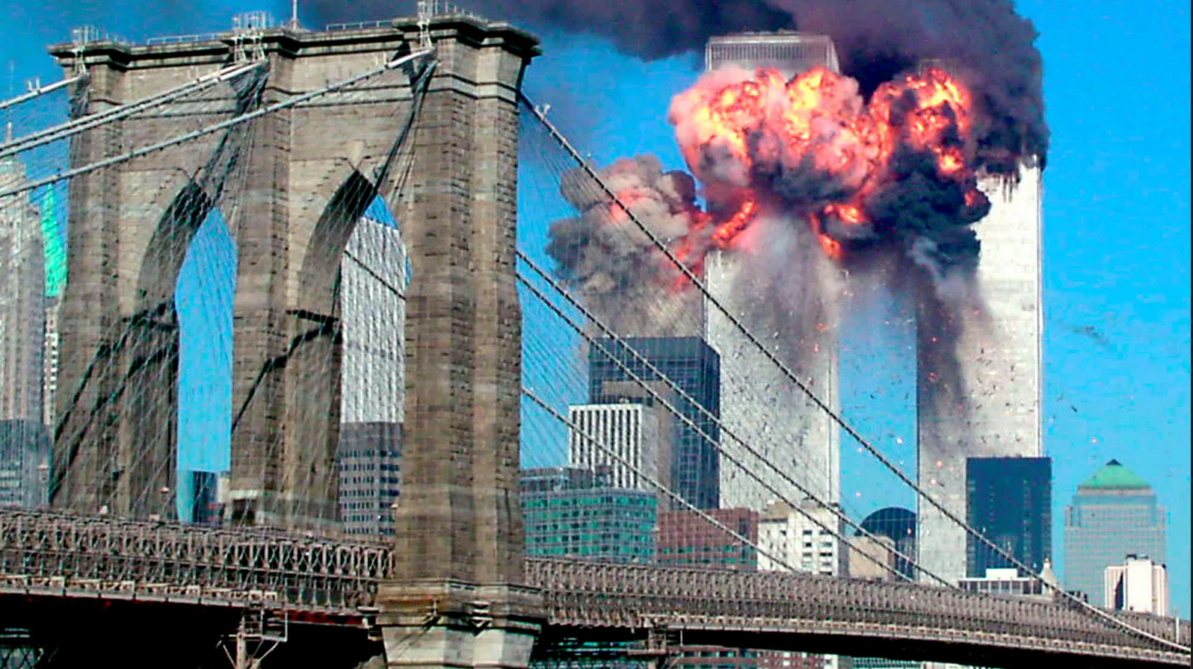
REMEMBERING SEPTEMBER 11, 2001
Dear Lakesiders and friends,
Each year on the anniversary of 9/11, the families of victims gather for a ceremony on the 9/11 Memorial Plaza to read aloud the names of the 2,983 men, women, and children killed in the September 11, 2001 attacks and February 26, 1993 bombing of the World Trade Center. Six moments of silence mark the times when each of the World Trade Center towers was struck, when each tower fell, and the times corresponding to the attack at the Pentagon, and the crash of United Airlines Flight 93 in Pennsylvania.
Of the last 25 people who made it out of the World Trade Center's south tower on Sept. 11, 2001, Florence Jones was number 18. Her story is one that is emotionally told about the nightmare of 9/11 and reported on by David Muir of ABC. She says: “Sept. 11, 2001, was a beautiful morning, until it wasn’t.” Like so many, Florence has long described the clear, blue skies, and the kindness on full display. That morning was like so many others, until as she says, it descended into hell on Earth.
Florence worked as a manager on the 77th floor of the south tower. The north tower was hit first, and she remembers going up to 78th floor to tell colleagues they should leave. She went back down the escalator to the 77th floor and moments later, the second plane hit - just one floor above her. Many of the colleagues she had just seen were now gone, including Jill Maurer Campbell, a young mother. Florence has always said she will never forget Jill’s smile, especially the day Jill brought her baby boy, Jake, to the office.
When the second plane hit, Florence had to find her own way to escape. She joined a small group of colleagues and started down the smoke-filled stairwell, holding hands, holding each other’s shirts, guiding one another. She remembers her boss, fearing Florence might fall on the way down, suggesting she take her shoes off. He carried her shoes the rest of the way down. They helped each other out. For years, those debris-covered shoes sat in a box under her bed. Now, they’re in the 9/11 museum.
Florence survived the attack on the twin towers and ever since, has always conveyed a quiet sense of purpose, a sense of responsibility after having survived that dark day. She has shared so many deeply personal reflections. For one, she will never forget looking out and seeing men and women in the north tower standing at the window’s edge after the first plane hit.
“To see these young people doing the sign of the cross and jumping. You’re like, oh my God,” she told me. Where was God on September 11, 2001? Just as he said of the Holocaust, Rabbi Greenberg says when asked where was God? God was where God ought to be – with the suffering, oppressed, dying and desperate.
Now it is our responsibility to remember, to pray, and to live so that such a event of horror never happens again.
In forgiving Love,
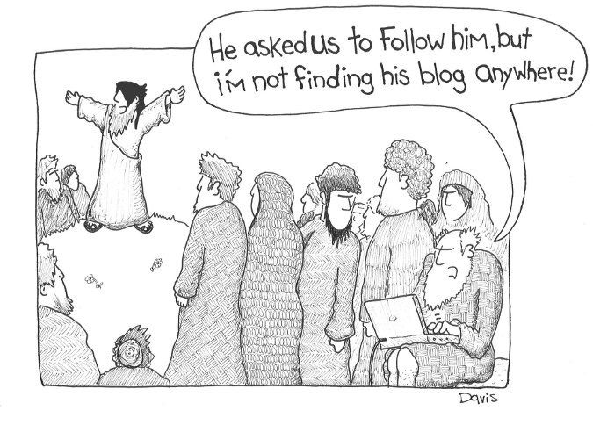
Roger

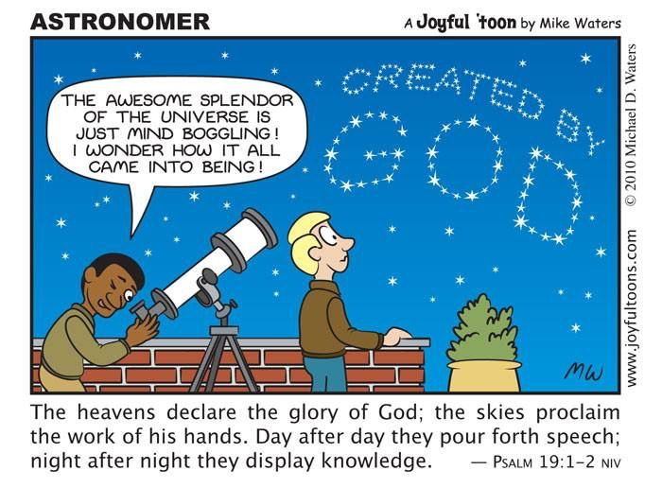
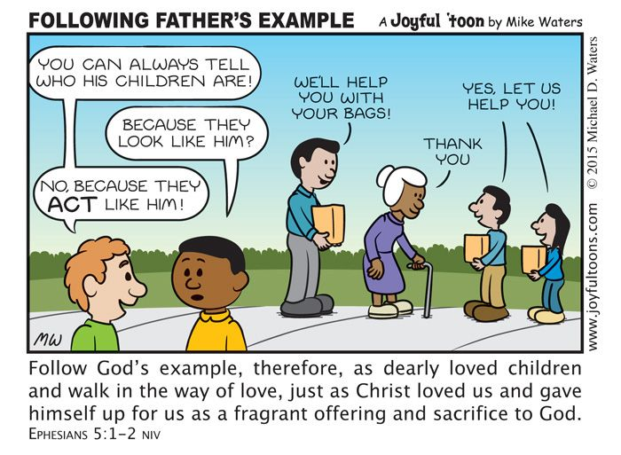
WORLD WIDE COMMUNION and PEACE AND GLOBAL WITNESS OFFERING
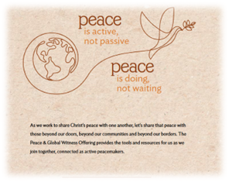
World Communion Sunday (originally called World Wide Communion Sunday) is a gift of the Presbyterian Church to the larger global Christian Community.
World Communion Sunday began at Shadyside Presbyterian Church in Pittsburgh, Pennsylvania in 1933. The Rev. Hugh Thompson Kerr and his congregation sought to demonstrate the interconnectedness of Christian churches, regardless of denomination.
Davitt S. Bell (the late Clerk of Session and church historian at Shadyside) recalled that Dr. Kerr first conceived the notion of World Communion Sunday during his year as moderator of the General Assembly (1930). Dr. Kerr’s younger son, the Rev. Dr. Donald Craig Kerr, has related that World Communion Sunday grew out of the Division of Stewardship at Shadyside. It was their attempt to bring churches together in a service of Christian unity—in which everyone might receive both inspiration and information, and above all, to know how important the Church of Jesus Christ is, and how each congregation is interconnected one with another. When I asked Donald Kerr how the idea of World Communion Sunday spread from that first service to the world wide practice of today, this is what he replied, “The concept spread very slowly at the start. People did not give it a whole lot of thought. It was during the Second World War that the spirit caught hold, because we were trying to hold the world together. World Wide Communion symbolized the effort to hold things together, in a spiritual sense. It emphasized that we are one in the Spirit and the Gospel of Jesus Christ.”
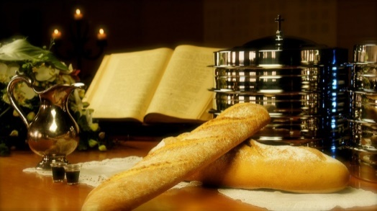
Celebration of World Wide Communion Sunday was adopted as a denominational practice in the Presbyterian Church (US) in 1936. Churches in other denominations were invited to celebrate with us from the beginning, but it wasn’t until 1940 when the Department of Evangelism of the Federal Council of Churches (a predecessor body of the National Council of Churches) promoted extending the celebration to a number of churches around the world that the practice became widespread. Today, World Communion Sunday is celebrated around the world, demonstrating that the church founded on Jesus Christ peacefully shares God-given goods in a world increasingly destabilized by globalization and global market economies based on greed.
In the Presbyterian Church USA, a special offering is collected on World Communion Sunday called the Peace & Global Witness Offering. You may participate in this wonderful opportunity to share God’s peace and love with the world by placing your offering in the envelopes provided in your envelope box or on the table in the back of the sanctuary. The deadline is Sunday, October 1.

