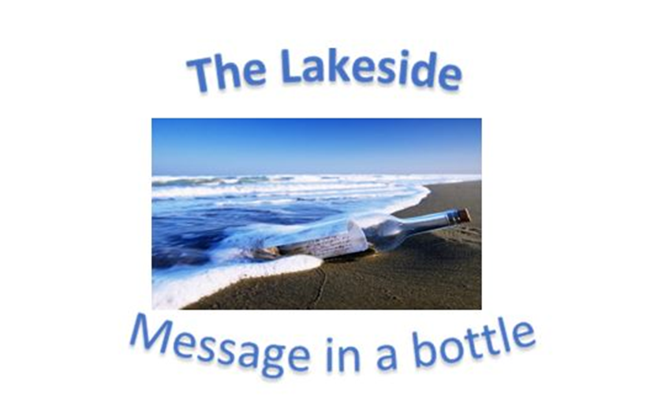
Verse of the day for Monday August 28 2023 – Psalm 19:1

1 The heavens declare the glory of God; the skies proclaim the work of his hands.

Read Psalm 1 for meditation and inspiration.
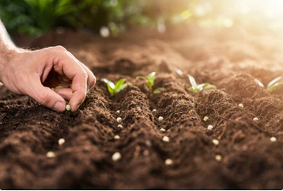

THE TIME FOR PLANTING!
Dear Lakesiders and friends,
Someone once said that: “Evangelism is simply one beggar telling another beggar where to find bread.”
I like that because so often I hear that evangelism is something that is offensive, it is out of date, out of style. People in this accepting society feel that to evangelize is to imply that “Mine is better than yours.” “You are wrong, and I am right.” “I have something that is superior and yours is inferior.”
For me evangelism is telling a story, “My Story,” of where I have found bread that for me is the bread of life. And that story is simply planting a seed, which with care and nurture God, the Holy Spirit will use to produce fruit. But for that to happen the seed must be planted.
One spring day, a gardener showed his neighbor a packet of seeds he had just purchased. The seed envelope pictured a beautiful array of exotic flowers. “I'm hoping this will be my best flower garden ever," the man told his neighbor. A month later, the neighbor again stopped by and asked, "How's your flower patch doing?"
“I'm sorry to say it hasn't done very well," the gardener replied. "That's a shame. Was it bad soil? Pests? The hot weather?" the neighbor inquired. The man shook his head. "Then maybe your seed was the problem," the neighbor suggested. "Yeah, I suppose the seed was the problem," the man admitted. "You see, I never got around to planting it!"
Getting the seed into the ground can sometimes be the hardest part of growing things, especially in first-century Israel. In the days of Jesus, managing a meager harvest from the land was a back-breaking struggle. The area itself was the first obstacle. Palestine is a hilly country and much of the planting is done on ground that is not easily prepared for the planting. When Jesus tells of the seed that falls on hard ground, or weed infested ground, or with little soil or does not penetrate so it is no more than bird food, people understand exactly what he is talking about. And when he then shifts over to say that it is the same for the planting of the Gospel message, they can get that too.
But planting is the start. Planting is the hope for a harvest. Planting is the job given to us and God will produce the growth as He wills.
Be good planters and watch as God grows others into Christ followers, Lakeside Presbyterian Church grows into a vibrant congregation that reaches out into the community, and His Kingdom is glorified by people who choose a relationship with Him.

In the Planting Spirit,

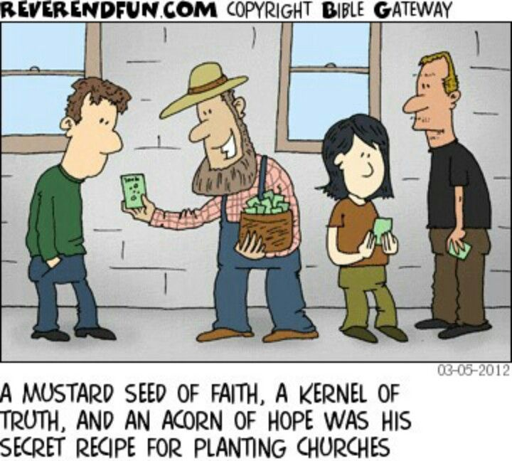
Roger

