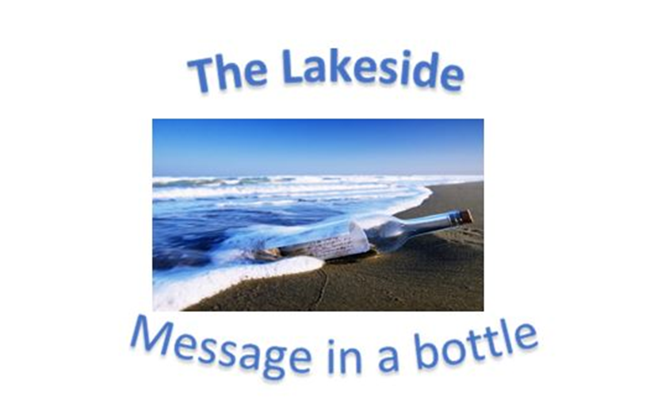
Verse of the day for Monday August 14 2023 – II Thessalonian 2: 16-17

16 May our Lord Jesus Christ himself and God our Father, who loved us and by his grace gave us eternal encouragement and good hope,
17 encourage your hearts and strengthen you in every good deed and word.

Read II Thessalonians 2 for meditation and inspiration.
“I AM THE WAY, THE TRUTH, AND THE LIFE”
Dear Lakesiders and friends,
Fake News is a term that we all have seen thrown around. It is used for news with clear facts to support the news story and for news stories that are made up of fabrication and deception. This idea of “alternative facts” seems to be a fevered pitch since the war in Ukraine. Russia’s invasion of Ukraine on February 24, 2022 was followed by an information war — with a large-scale disinformation campaign, targeted propaganda and conspiracy theories, especially on social media.
A wise person once said, "I've learned that to ignore the true facts, does not change the facts." Which reminds me of the story of a man who had become an expert in ignoring certain difficult facts. The man, who was getting on in years observed, "Everything is farther away than it used to be. It's twice as far to the corner, and I've noticed that they've added a hill. I've given up running for the bus. It leaves faster than it used to. I ran across an old school friend the other day, and he had aged so badly that he didn't recognize me. I got to thinking about him this morning as I was combing my hair and glanced at my reflection. They don't make good mirrors anymore, either."
It has been said that the cause of humanity has suffered much at the hands of people who do what they think God would do if only He knew the facts. In today's Gospel Lesson, Jesus tells the story of two men, one of whom is in the act of praising himself as he thinks God would praise him if only He knew the facts. And since he is in the Temple, he finds it convenient to let God in on the facts. "I am not like other men," he tells God. "I am not an extortioner. I am not unjust. I am not an adulterer. I am not like that sinner standing over there. I give my fair share to the temple treasury.”
Here is a fact that you can take to the bank - no you can take it to the treasury in heaven. God loves a humble heart. God honors one who knows that he is a sinner and in need of God’s mercy - His sacrificial forgiving love. Then as Romans 10:9 declares: “If you declare with your mouth, “Jesus is Lord,” and believe in your heart that God raised him from the dead, you will be saved.”
In God’s saving mercy,
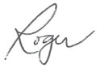
Roger
