Verse of the day for Monday July 17 2023 – III John 1:11

11 Dear friend, do not imitate what is evil but what is good. Anyone who does what is good is from God. Anyone who does what is evil has not seen God.
Read III John 1 for meditation and inspiration.

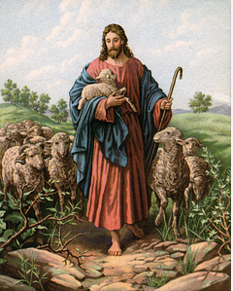
THE GOOD SHEPHERD
Dear Lakesiders and friends,
Do you remember how Jesus said, “I am the Good Shepherd?” Can you recall that Jesus claimed, "The sheep that belong to Me listen to My voice; I know them and they follow Me." (John 10:27) Sheep must follow because they hear and trust the shepherd’s familiar voice.
When asked to explain the differences between herding cattle and tending sheep, a Texas rancher explained: “You've got to herd cows. We know they act in predictable ways, shying away from someone waving a stick at them. They also know enough not to get too concerned when they see that stick. They just don't panic easily.
On the other hand, sheep are not smart enough to herd. Sheep, out of their ignorance, panic easily. To handle sheep, the shepherd must condition them to trust and to follow. You can't herd sheep like cows. You must lead them. For their safety and survival, sheep need to rely on their relationship with the shepherd. It's easy to see why Jesus identifies Himself as the Good Shepherd - not the Good Cowboy!”
Jesus says, "The sheep that belong to Me listen to My voice; I know them and they follow Me. I give them eternal life" (Jn. 10:27-28).

Tha Jesus depicts His relationship with us in terms of Shepherd and sheepfold should come as no surprise to us. Jesus frequently employed this imagery because sheep herding was the primary profession of His people. They understood well the relationship between a good shepherd and his flock. We who follow him are the sheep of his pasture and we are learning to trust and obey, for there is truly no other way to be happy in Jesus but to trust and obey.

Remaining in his flock,

Roger
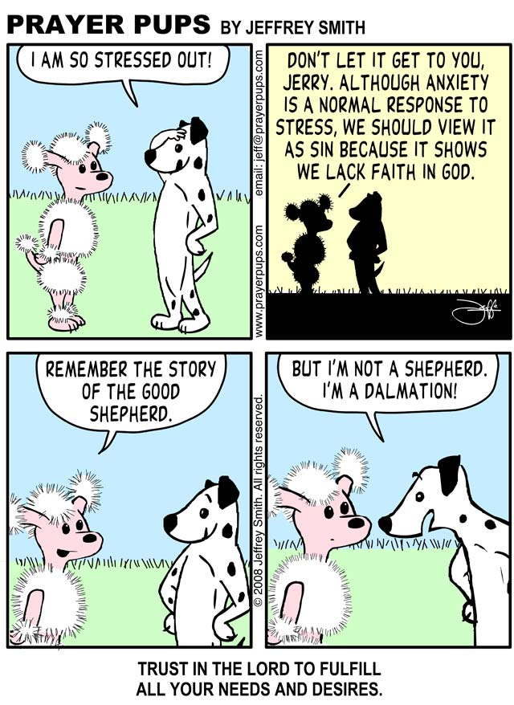
BEWARE OF SCAMMERS (a note from Dr. Richardson)

Dear Lakeside Members,

I really wish that I would not have to write something like this but I do not want our members to be fooled in this way! We have been made aware of “church related scams” that have affected some of our Tropical Florida Presbytery churches as well as members of Lakeside. One of the scams features someone posing as the church pastor asking a church member specifically for a gift card, auto transfer of funds or a gift in bitcoins to help someone in need and promising to pay back whatever funds are spent. Please understand I will NOT solicit funds this way. We do have our regular ongoing stewardship program/drive and occasionally seek funds for church programs or repairs BUT other than that NO, NO, NO! Please do NOT think that I will ever ask for anything to be sent directly to me for any reason. Any requested donations will always be sent directly to LAKESIDE PRESBYTERIAN CHURCH!

Roger P. Richardson

