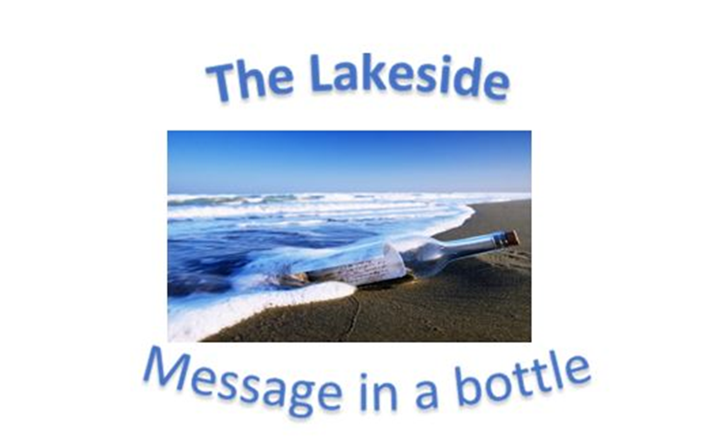
Verse of the day for Monday July 3 2023 – Galatians 5:1

1 It is for freedom that Christ has set us free. Stand firm, then, and do not let yourselves be burdened again by a yoke of slavery
Read Galatians 5 for meditation and inspiration.
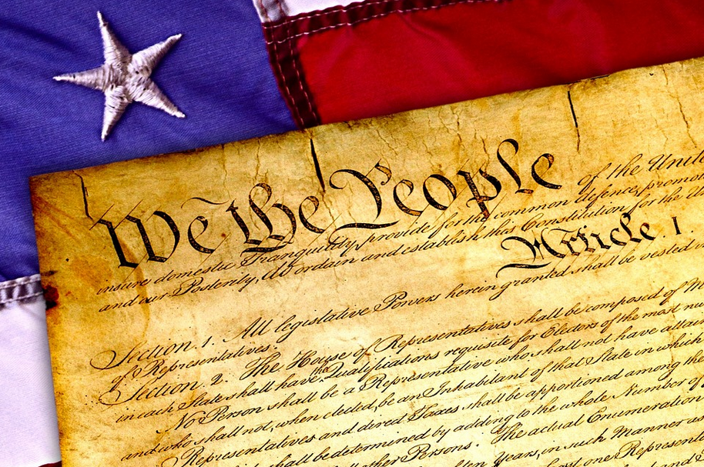
HAPPY FOURTH OF JULY
Dear Lakesiders and friends,
We live in an age of divisiveness. People have become tribal; banding together by ethnic, religious, orientation, cultural and heritage. It also seems that being suspicious of others is commonplace and being hostile toward any supposed threat is normalized. This is not the first time in American History that division has reared up.
Abraham Lincoln knew all too well the devastation of divisiveness and the fight to remain as “one nation under God.” He said the following in 1858. He refers to the Constitution geared to end slavery imbedded in its text: So, after expounding upon the evils of slavery and recent actions to preserve the institution Lincoln turns to the Declaration of Independence for support. He stated,
“We hold this annual celebration to remind ourselves of all the good done in this process of time of how it was done and who did it, and how we are historically connected with it; and we go from these meetings in better humor with ourselves—we feel more attached the one to the other and more firmly bound to the country we inhabit. In every way we are better men in the age, and race, and country in which we live for these celebrations. But after we have done all this, we have not yet reached the whole. There is something else connected with it. We have besides these men—descended by blood from our ancestors—among us perhaps half our people who are not descendants at all of these men, they are men who have come from Europe—German, Irish, French and Scandinavian—men that have come from Europe themselves, or whose ancestors have come hither and settled here, finding themselves our equals in all things. If they look back through this history to trace their connection with those days by blood, they find they have none, they cannot carry themselves back into that glorious epoch and make themselves feel that they are part of us, but when they look through that old Declaration of Independence they find that those old men say that “We hold these truths to be self-evident, that all men are created equal,” and then they feel that that moral sentiment taught in that day evidences their relation to those men, that it is the father of all moral principle in them, and that they have a right to claim it as though they were blood of the blood, and flesh of the flesh of the men who wrote that Declaration, (loud and long continued applause) and so they are.
That is the electric cord in that Declaration that links the hearts of patriotic and liberty-loving men together, that will link those patriotic hearts as long as the love of freedom exists in the minds of men throughout the world.”
These self-evident truths were given to humans or “as humans found themselves endowed by their Creator.” When we accept each other as children of God, made in God’s very image we are both living out our faith and our patriotism.
May God Bless America and forgive and mend her every flaw.

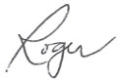
Happy Fourth of July,

Roger
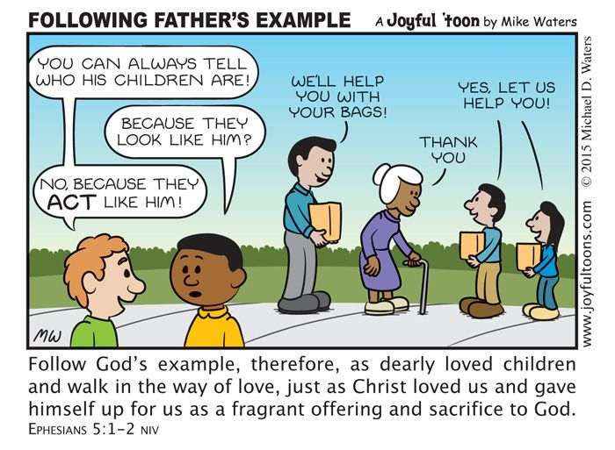

ON THE CHURCH CALENDAR:
  - July 4 – Fourth of July
  - June 5 – AA Meeting – in person – 6:30 pm
  - July 7 – Youth Bowling - – in person – 6:30 pm
  - July 8 – VBS – in person at Faith Presbyterian – 9:00 am
  - July 9 – Worship Service – in-person and online – 10:30 am
  - July 10 – Session Meeting – online – 7:00 pm
  - July 12 – Ladies’ BYOL and Bible Study – in person – 11:30 am

PRAYERS FOR THE PEOPLE:
    - Family and Friends of Frank Arther Clark (grandfather of Clara Hodges and Colin and Clark Aliapoulios)
    - Reverend Robert J. Collins
    - Nancy Anthony
    - Greg Aronson
    - Sue Askeland (friend of the Pughs)
    - Nancy Bailey
    - Bob Beatty (friend of Hunter Morgan)
    - Bob Beekman – (friend of Nancy Jones with cancer)
    - Lou Berdoll – (brother of Larry Berdoll)
    - Judy Breeden
    - Amy Clark – (mother of Clara Hodges)
    - Tony Deisch
    - Ferguson family
    - Dean Ferguson
    - Heather Ferguson
    - Martin Flanagan
    - Janet and Ed Ginty (friends/clients of Christine Stewart)
    - Bonnie Gordon – friend of Nancy Jones with cancer
    - Kyle Gordon – (friend of Susan Morgan)
    - Janice Hobbs
    - Bob and Gail Howell
    - Dixie Jarvis
    - Kathy Kopplow
    - Ellie Manzano
    - Mark Martel
    - Andrew Martin (son of Jay Martin)
    - Helen Martin
    - Brinsley Matthews (friend of Susan Morgan)
    - Bill Maybury
    - Maybury family
    - Sandra McPeters (niece of Nancy Brock)
    - Donna Miglets (niece of Nancy Mae Beggrow)
    - Jan Monroe – surgery July 25
    - James Morgan (son of Deborah Morgan)
    - Martha Musgrove
    - Amy Nesbit (friend of Marge Sarrigar)
    - Raquel Peterson (friend of Deborah Morgan)
    - Mary Alice Pugh
    - Annette and Brian Ramkerrysingh
    - Jane Richards (sister of Nancy Brock)
    - Richardson family
    - Sandy – friend of Nancy Bailey and Fran Thew
    - Marge Sarringar
    - Jack Schultze
    - Marilyn Schneider – broken back
    - Jeff Seemann (brother of Ken Seeman)
    - Diane Stellwagon (friend of Toni Edwards)
    - William Stewart (son of Chris Stewart)
    - Ray Terry (neighbor of Nancy Bailey)
    - Mark Thompson (brother of Scott Thompson)
    - Joyce Viola
    - Diana Walton
    - Lakeside Presbyterian Church and its leadership team
    - Palm Beach Harvest and its invaluable ministry bringing food to the food insecure people of South Florida
    - Youth Ministry of Lakeside – making disciples of the new generation

FOURTH OF JULY LUNCHEON – JULY 2, 2023
