**EASTER WEEK**

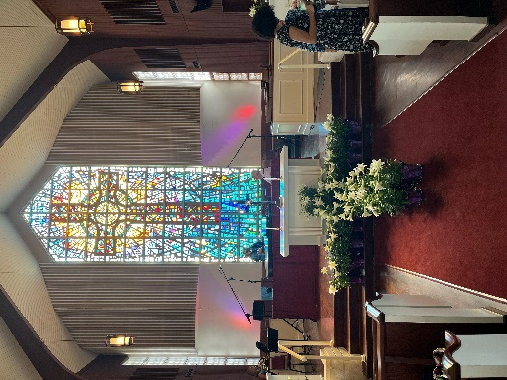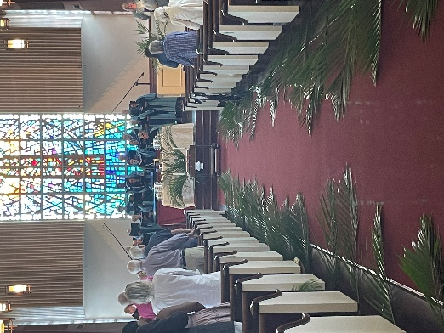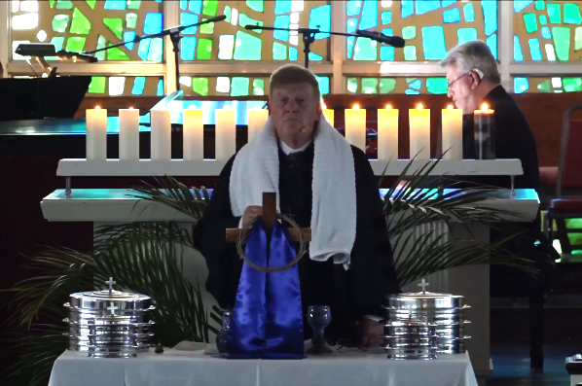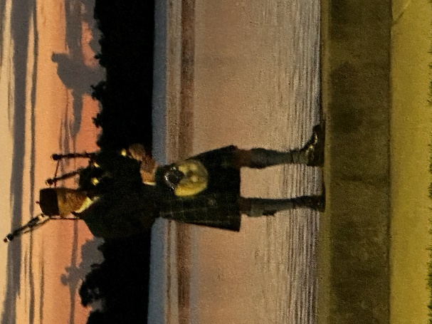

**Easter Brunch**

**As the sun rose on Easter Sunday**

**Easter Bonnets**

**Easter Sunday**

**Maundy Thursday Tenebrae Service**

**Palm Sunday**